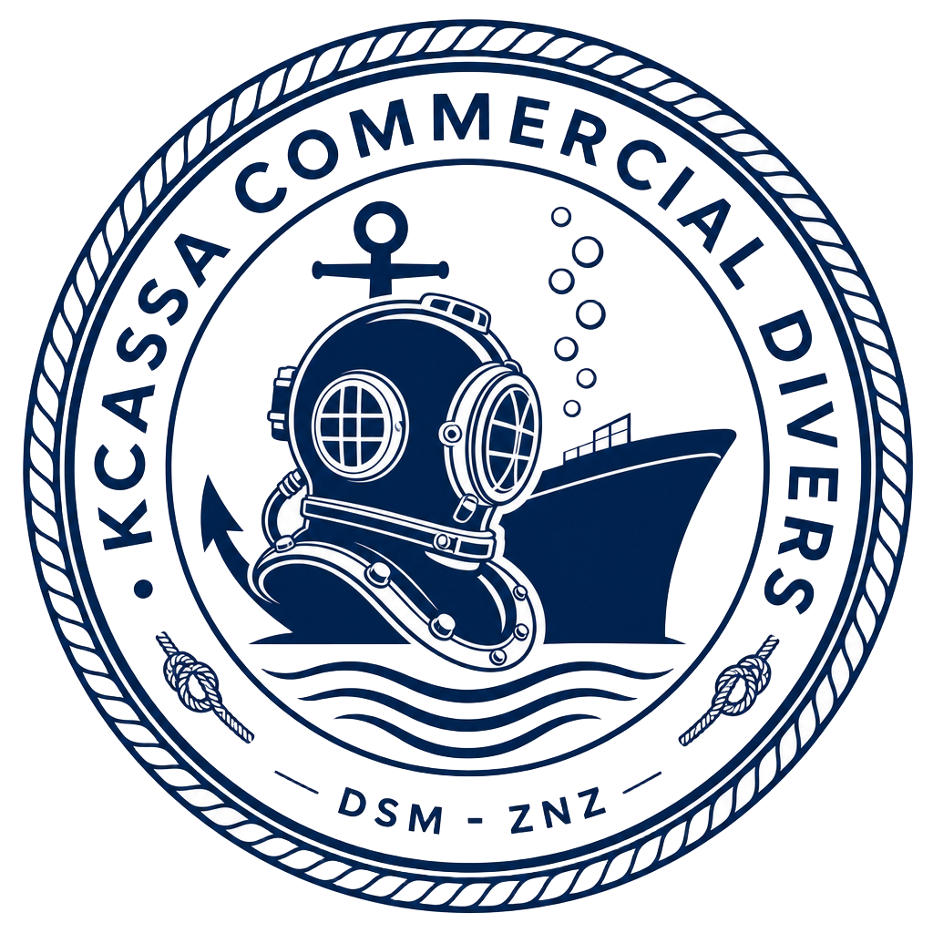 | KCASSA COMMERCIAL DIVERS  A Subsidiary of KKASA Marine Construction Limited  UNDERWATER WORKS  OFFICE P.O. Box 17532, Kigamboni, Dar es Salaam, Tanzania  CONTACT +255 764 665 588 | +255 747 944 429  ADDITIONAL CONTACT +255 790 779 882  WHATSAPP +260 770 918 088  EMAIL kcassacommercialdivers@gmail.com

EQUIPMENT SPECS
1. 3 DIVER SRP (SCUBA REPLACEMENT PACKAGE)

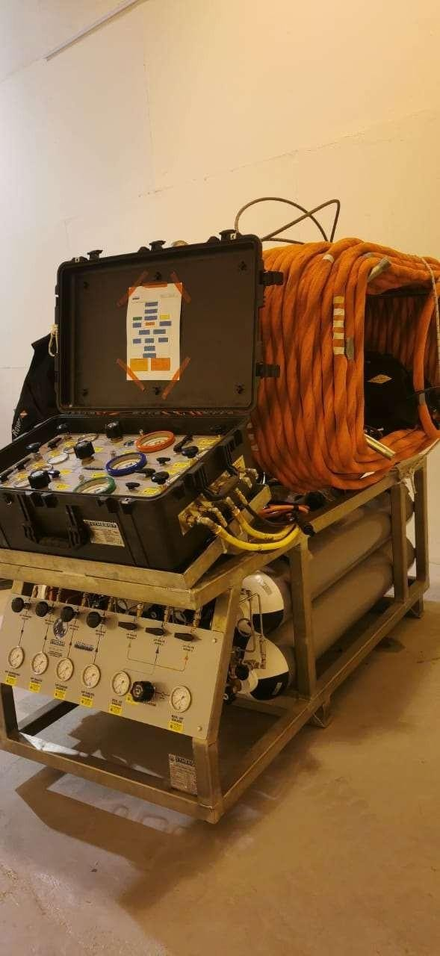

Technical Data Sheet:

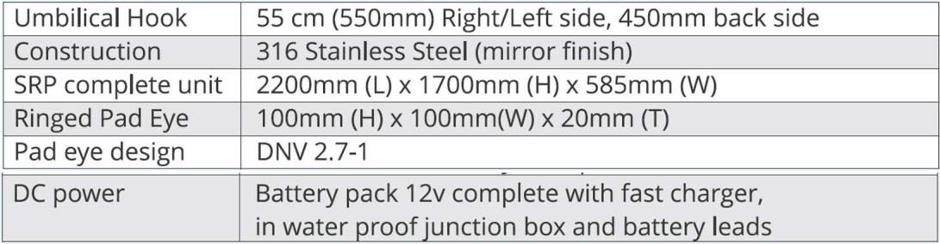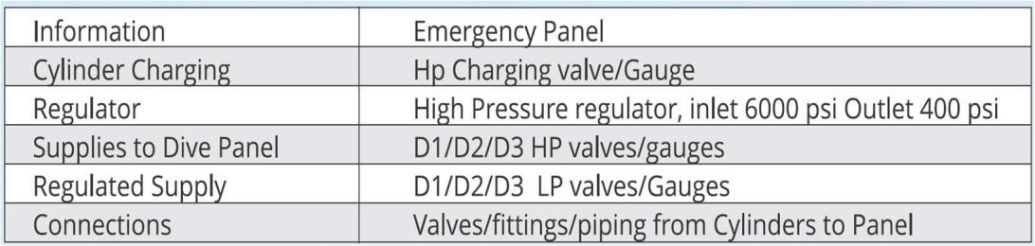
3 DIVER DIVING PANEL WITH 2 DIVER CCTV UNIT INCL. COMMS BOX

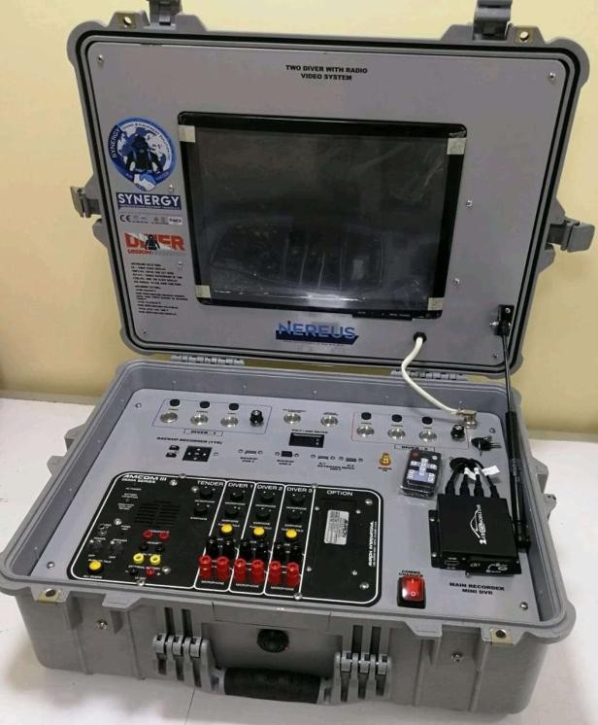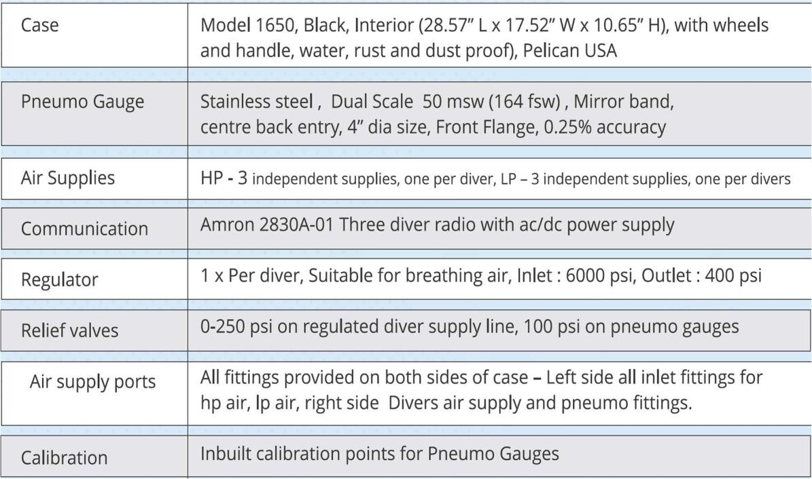

CCTV UNIT
Monitor | 15.5” (With splitter for Diver 1 & Diver 2)
Surface Control Unit | Video/ Light control
CCTV Recording | Mini DVR 128 GB with Blackbox recorder 1TB
International Certification | IMCA D040

Diver 1 & Diver 2 Umbilical is 4 Core: 150 m Each
Diver 3 Umbilical is 3 Core: 150 m

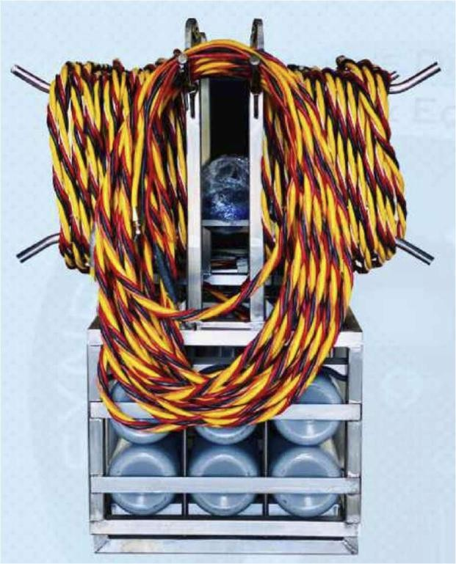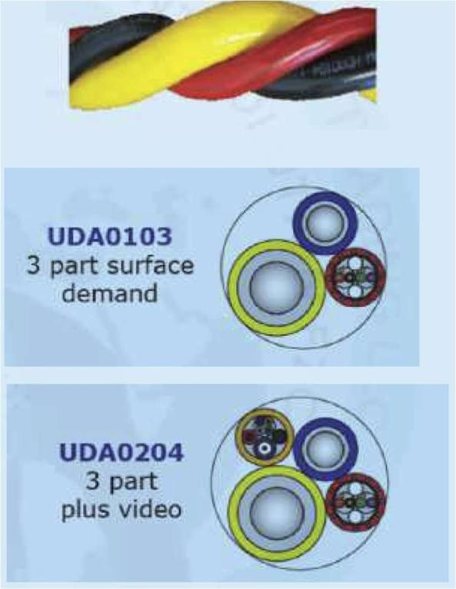

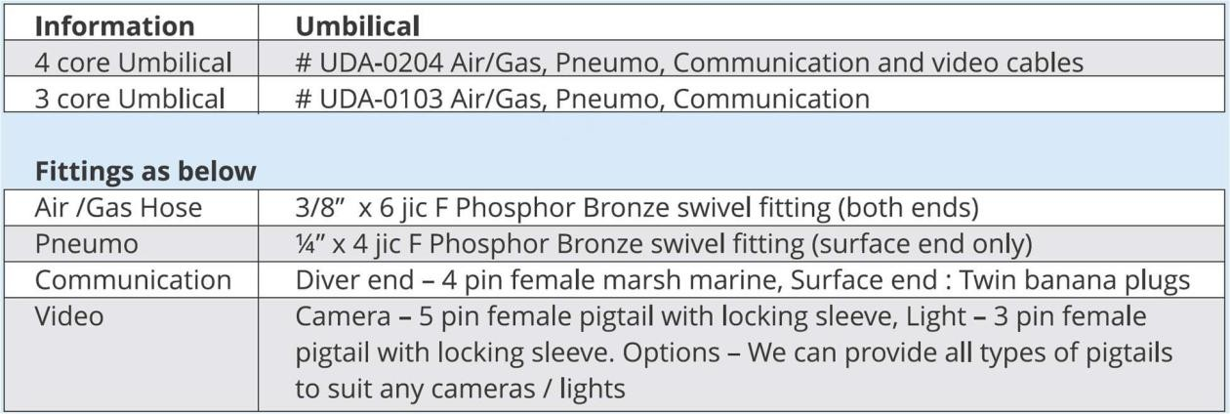
- BAUER MARINER IID BREATHING AIR COMPRESSOR:

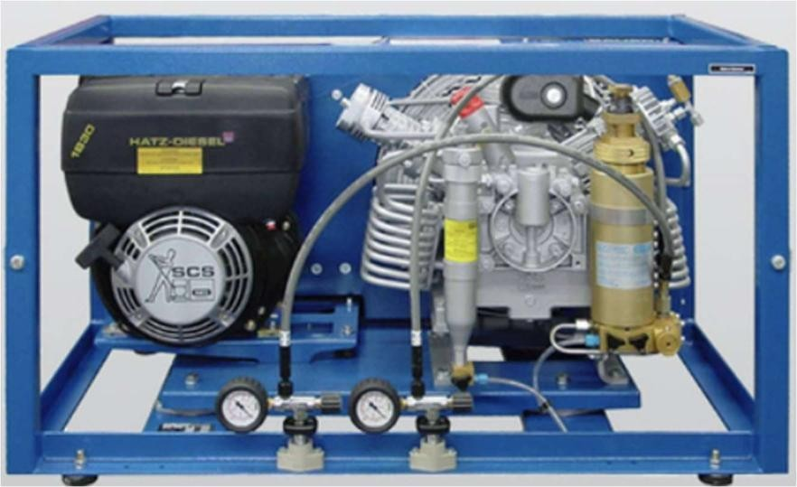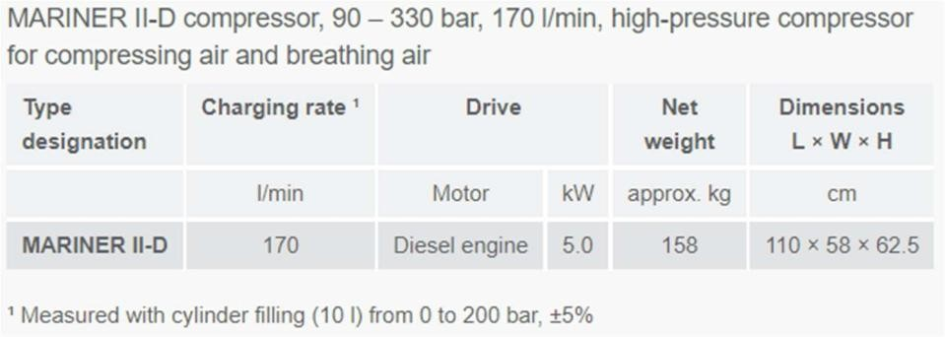

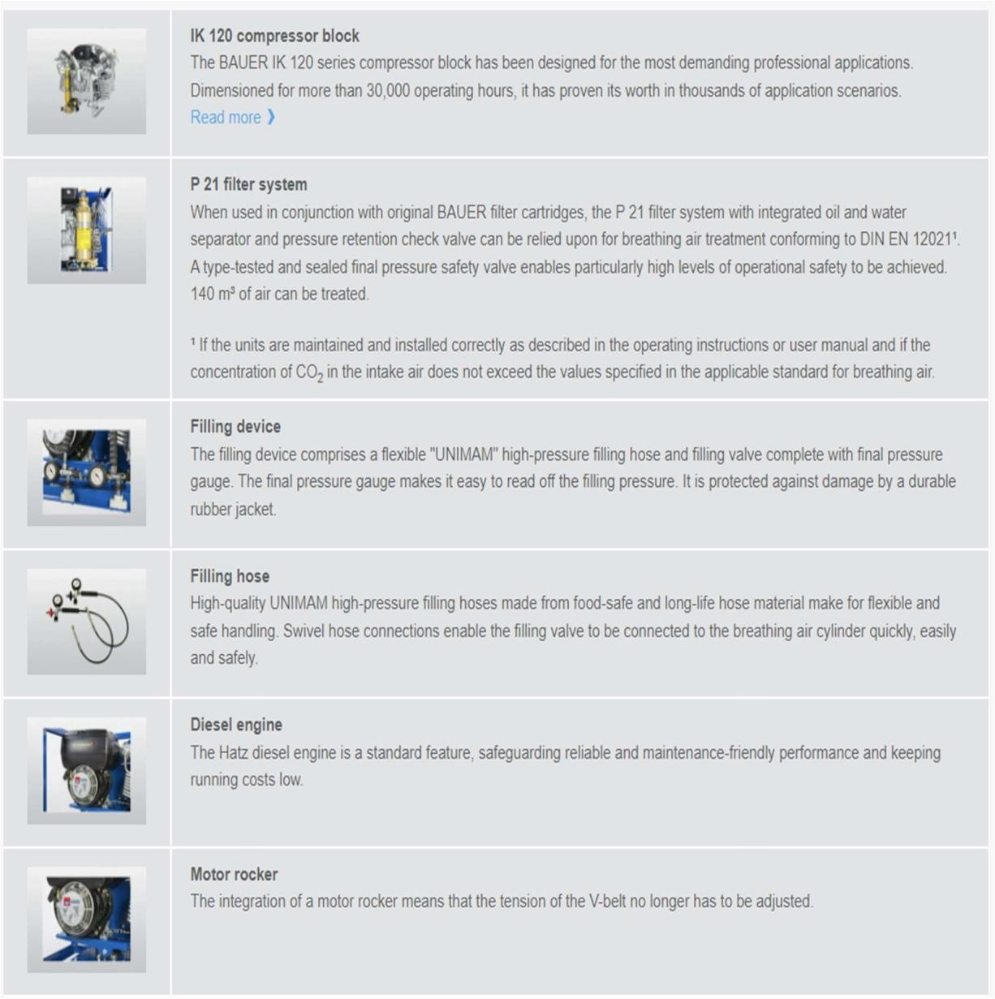
- Triple Brush Head- Hebraically operated BRUSHKART: 2 Nos

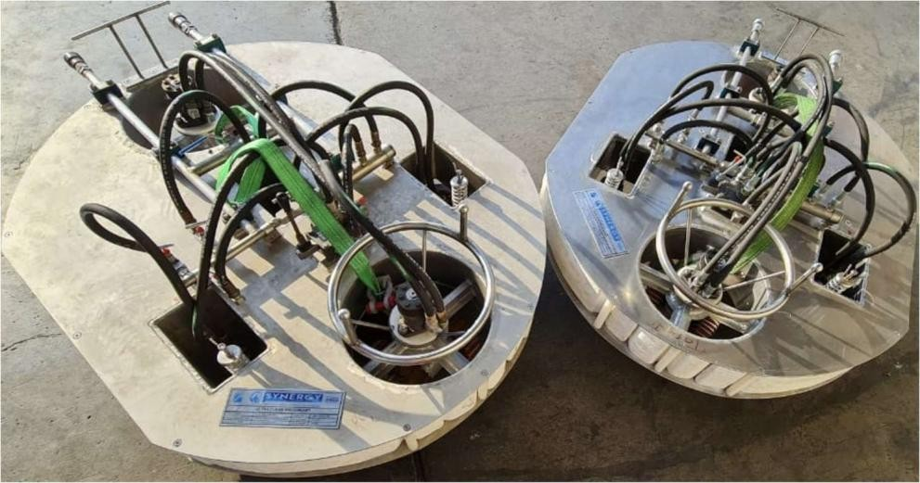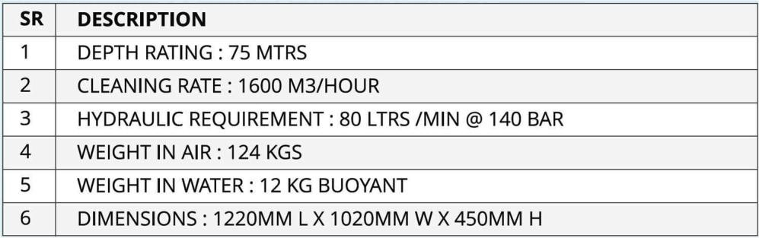
- Brushes:
Underwater hull cleaning is carried out to remove the buildup of marine fouling which causes increased drag and can have a direct impact on the vessels hull performance. Using hydraulically powered, diver driven; brush karts fitted with specialist tried and tested hull cleaning brushes. Our brushes are capable of removing light fouling such marine slime and heavy fouling such as barnacles.
NEREUS uses a wide variety of brushes during hull cleaning operations. The brushes are selected by the Diving Supervisor based on the vessels coating system and the extent of marine fouling encountered.

Polyester Bristle Brush: Light Duty  Used for Light Slime | Polyester Bristle Brush: Medium Duty Used for Medium Slime and Grass
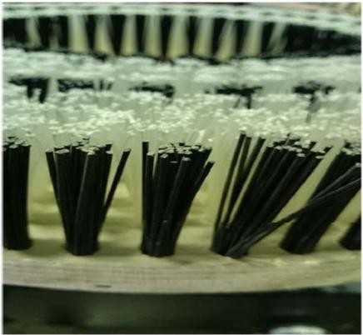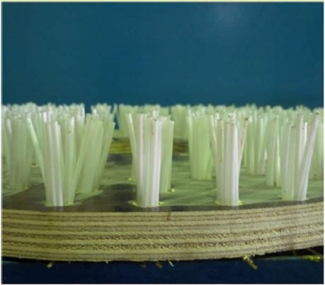

Soft Wire Brush – Light Duty Wire Brush with Cutters- Heavy Duty
Used for Heavy Sea Grass Used for Medium to Heavy Shell Growth

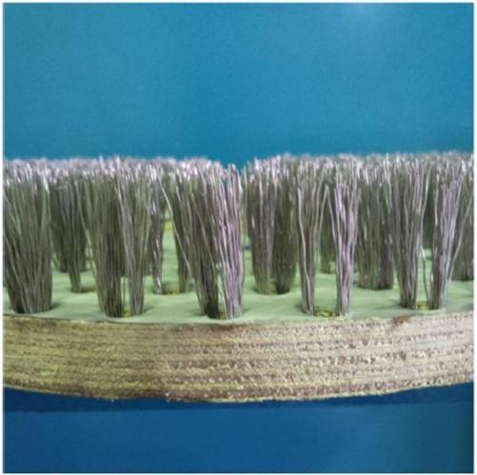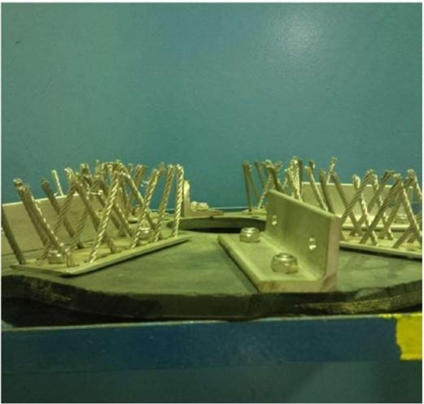
Polyester Bristle Brush – Heavy Duty Polyester Bristle Brush – Specialized Coating Used for Heavy Slime and Heavy Grass Used For SPC coating

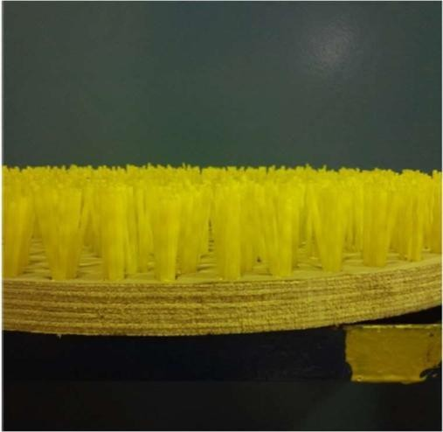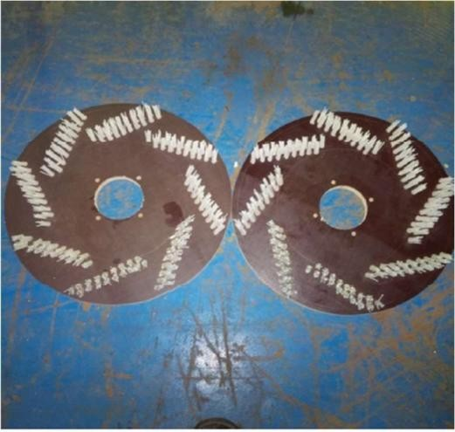
- Wheels :

EACH BRUSHKART is mounted with 4 PU coated paint safe WHEELS

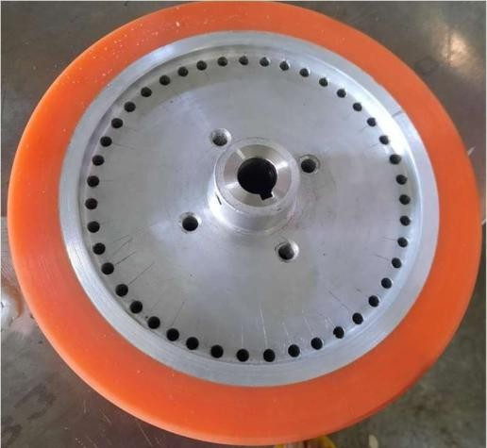
- PROPELLER POLISHING HYDRAULIC UNIT: 2 Nos

NEREUS provides Multi stage micro polishing of all propeller blades surfaces, with detailed written
report stating any abnormalities sighted during the general inspection. (Including pre- and post-polishing photographs). Solutions are available for vessels at anchorage.

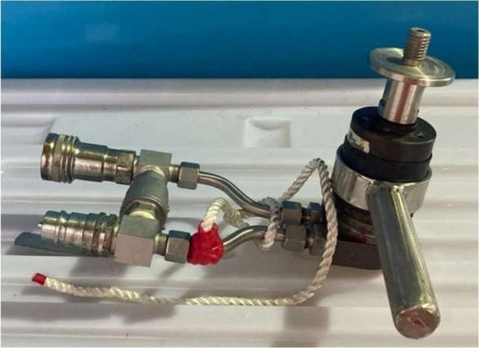

TYPE 1: POLISHING PAD (Silicon Carbide) Type 2 : Diamond Pad Type 3: 3M Super Polishing Pads

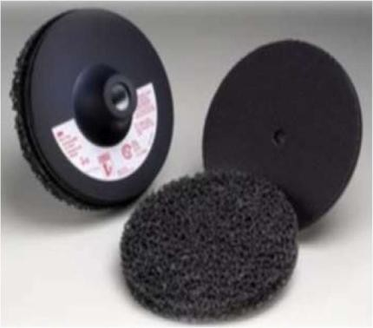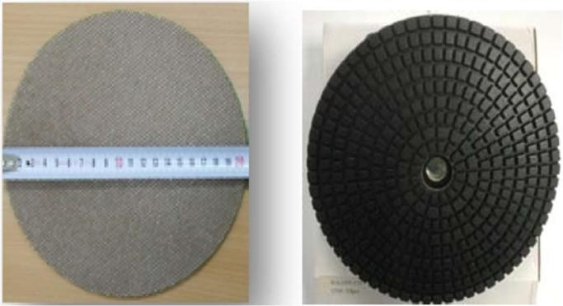

RUBERT SCALE

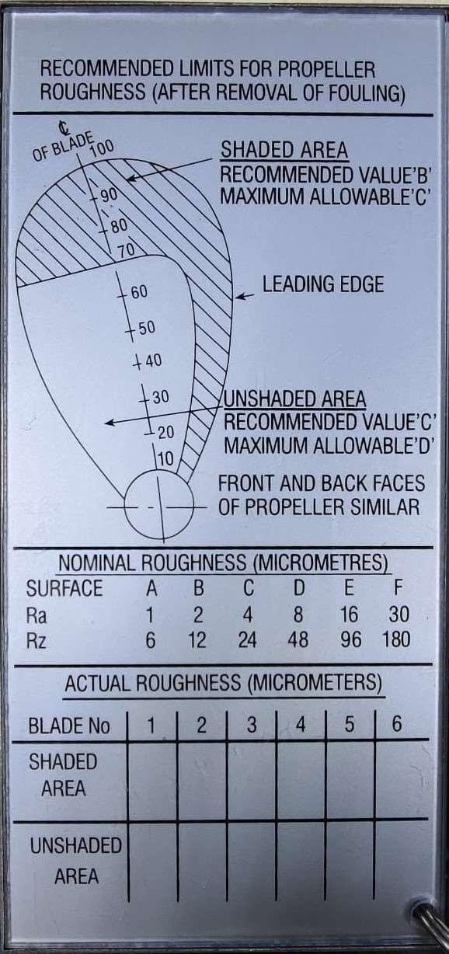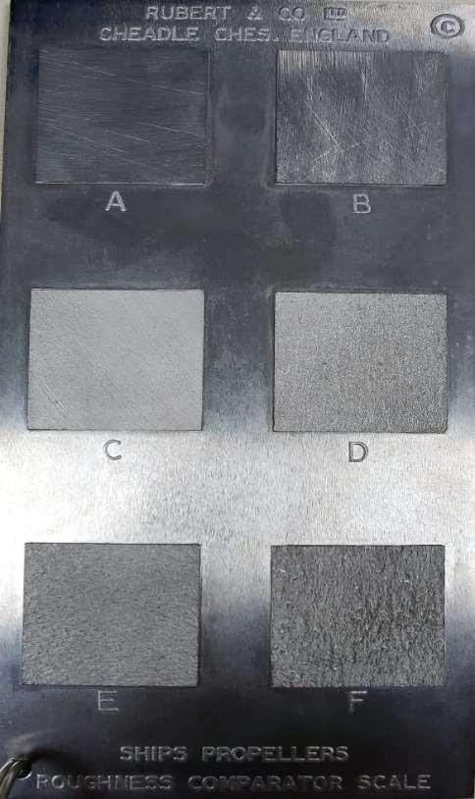
- HYDRAULIC POWERPACK:
Maximum working Pressure: Pump 1 & 2 :150 Bar
Pump 3: 200 Bar
320 lpm flow Rate
Capable to run: | 2 BRUSHKART with 1 Propeller Polishing units  OR  1 BRUSHKART with 2 Polisher Unit

